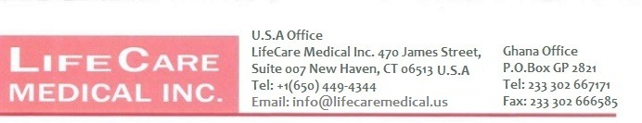

Date: February 02, 2026
SQ NO.: CR/SLCH/GD/001/25

To: ST. LUKE’S CATHOLIC HOSPITAL
P. O. BOX AP 5,
APAM
CENTRAL REGION

WHEREAS

We, LIFECARE MEDICAL INCORPORATED
who are established and reputable manufacturers of

Diagnostic Equipment, Therapeutic Equipment, Monitoring Equipment, Life Support Equipment, Surgical Instruments, Medical Furniture and Fixtures and
having factories at 470 James Street, Suite 007 New Haven, CT 06513, USA.

do hereby

- Authorise BEAUTIFUL CREATIONS LIMITED to submit a Tender in response to the Invitation for Tenders indicated above.


- Extend our full guarantee and warranty in accordance with Clause 33 of the General Conditions of Contract, with respect to the goods offered in the Tender.

Signed In the Capacity of Vice President Name: LIFECARE MEDICAL INCORPORATED
Duly authorized to sign the authorization for and on behalf of LIFECARE MEDICAL INCORPORATED

Dated on 2nd day of February, 2026.

